A Project Report on

Classification of AI Images and Real Images
using Deep Learning

Submitted in partial fulfillment for award of

Bachelor of Technology
Degree
in
Computer Science and Engineering
By

N.L.Prathyusha (Y21ACS521) M.V.Brahmaji (Y21ACS509)
P.Sai Vani(Y21ACS533) M.S.S.Rahul Gupta (Y21ACS498)

Under the guidance of
S. N. Chandra Sekhar, _{M.Tech}
Assistant Professor

Department of Computer Science and Engineering
Bapatla Engineering College
(Autonomous)
(Affiliated to Acharya Nagarjuna University)
BAPATLA – 522 102, Andhra Pradesh, INDIA
2024-2025
Department of
Computer Science and Engineering

CERTIFICATE

This is to certify that the project report entitled Classification Of AI Images and Real Images using Deep Learning that is being submitted by N.L.Prathyusha (Y21ACS521), M.V.Brahmaji (Y21ACS509), P.Sai Vani(Y21ACS533), M.S.S.Rahul Gupta (Y21ACS498) in partial fulfillment for the award of the Degree of Bachelor of Technology in Computer Science & Engineering to the Acharya Nagarjuna University is a record of bonafide work carried out by them under our guidance and supervision.

Date:

Signature of the Guide Signature of the HOD
S.N.Chandra Sekhar Dr. M. Rajesh Babu
Assistant Professor Assoc. Prof. & Head

DECLARATION

We declare that this project work is composed by ourselves, that the work contained herein is our own except where explicitly stated otherwise in the text, and that this work has not been submitted for any other degree or professional qualification except as specified.

N.L.Prathyusha (Y21ACS521)
M.V.Brahmaji (Y21ACS509)
P.Sai Vani(Y21ACS533)
M.S.S.Rahul Gupta (Y21ACS498)
Acknowledgement

We sincerely thank the following distinguished personalities who have given their advice and support for successful completion of the work.
We are deeply indebted to our most respected guide S. N. Chandra Sekhar, Assistant Professor, Department of CSE, for his valuable and inspiring guidance, comments, suggestions and encouragement.
We extend our sincere thanks to Dr. M. Rajesh Babu, Assoc. Prof. & Head of the Dept. for extending his cooperation and providing the required resources.
We would like to thank our beloved Principal Dr.N.Rama Devi for providing the online resources and other facilities to carry out this work.
We would like to express our sincere thanks to our project coordinator Dr. P.Pardhasaradhi, Prof. Dept. of CSE for his helpful suggestions in presenting this document.
We extend our sincere thanks to all other teaching faculty and non-teaching staff of the department, who helped directly or indirectly for their cooperation and encouragement.

N.L.Prathyusha (Y21ACS521)
M.V.Brahmaji (Y21ACS509)
P.Sai Vani(Y21ACS533)
M.S.S.Rahul Gupta (Y21ACS498)

Abstract

As AI gets better at producing realistic content, it will become increasingly important to address the growing concerns about the veracity of visuals it creates. An sophisticated image classification model is suggested as a solution to this problem in the fields of media, advertising, and security. This model incorporates strategic data augmentation, normalization, and dataset splitting, and it is trained rigorously on a variety of datasets using TensorFlow and a T4 GPU. Relying on the well known ResNet50 architecture for deep learning, the model adds further layers to enhance feature extraction and representation learning. Its effectiveness is further increased by the incorporation of dropout, batch normalization, and dense unit approaches. The model's potential to distinguish between actual and artificial intelligence-generated photos is demonstrated by preliminary results, which will greatly add to the current discourse on image authenticity.
Keywords— Deep Learning, ResNet50, Classification, AI, Real.

Table of Contents
Abstract v
List of Tables ix
List Of Figures x
List of Abbreviations xi
1 Introduction 1
1.1 Motivation 2
1.2 Software Requirements 3
1.3 Hardware Requirements 4
2 Literature Survey 5
3 System Analysis 6
3.1 Feasibility Study 6
3.2 Functional Requirements 7
3.3 Non – Functional Requirements 8
4 System Design 10
4.1 Introduction To System Design : 10
4.2 Use Case Diagram : 13
4.3 Activity Diagram: 15
4.4 Sequence Diagram: 19
4.5 Class Diagram: 20
5 System Implementation 22
5.1 Tools and technologies used: 22
5.1.1 UML Tools: 22
5.1.2 Programming Languages: 22
5.1.3 Programming Frameworks: 22
5.1.4 IDE: 23
5.1.5 Libraries: 23
5.2 Algorithm Details: 25
5.2.1 Dataset Details: 25
5.2.2 Preprocessing Details 25
5.2.3 Model Details: 29
5.2.4 Model Training Details: 32
5.2.5 Model Prediction Details: 37
6 Testing and Results 40
6.1 Testing 40
6.2 Output Screens 43
7 Conclusions And Future Scope 48
7.1 Conclusion: 48
7.2 Future Scope: 48
References: 50

List of Tables

Table 1.1 : Hardware Requirements 4
Table 6.1 : Non-functional Testing 42

List of Figures

Figure 4.1: System Architecture 11
Figure 4.2 : Use Case Diagram 14
Figure 4.3 : Activity Diagram 18
Figure 4.4 : Sequence Diagram 20
Figure 4.5 : Class Diagram 21
Figure 5.1 : ResNet50 Model Architecture 30
Figure 5.2 : Residual Learning Block 30
Figure 5.3 : Relu Activation Function 31
Figure 5.4 : Dropout layer overview 32
Figure 6.1 : Model Accuracy Plots 43
Figure 6.2 : Confusion Matrix Representation 43
Figure 6.3 : Classification Report 44
Figure 6.4 : Home page of our Project 44
Figure 6.5 : Selecting an Image 45
Figure 6.6 : Fake Image Uploaded successfully 45
Figure 6.7 : Fake Image is predicted as Fake 46
Figure 6.8 : Real Image Uploaded successfully 46
Figure 6.9 : Real Image is Predicted as Real 47

List of Abbreviations

CGI | - | Computer-Generated Images
Advfaces | - | Adversarial Face Synthesis
RAM | - | Random Access Memory
UML | - | Unified Modelling Language
Mesonet | - | Mesoscale Meteorological Network
RestNet50 | - | Residual Neural Networks

Introduction
In the wake of rapid advancements in artificial intelligence (AI), the integrity of visual content has come under scrutiny as AI-generated images become increasingly indistinguishable from real ones. This blurring of lines between reality and simulation raises significant concerns about the authenticity of digital media across various sectors, including media, advertising, and security. As AI algorithms continue to refine their capacity to create hyper-realistic visuals, there is a pressing need to develop robust mechanisms for discerning between genuine and synthetic imagery to maintain trust and credibility in the digital realm.

The pervasive presence of AI-generated images underscores the urgency for innovative solutions to address the challenge of authentication in visual content. Our project proposes a novel approach that harnesses advanced image classification methodologies and cutting-edge deep learning techniques to tackle this issue. By leveraging TensorFlow, a leading framework for machine learning, and the computational power of a T4 GPU, we aim to construct a sophisticated classification model capable of accurately distinguishing between real-world and AI-generated images, thereby offering a reliable means of verifying the authenticity of visual data.

As the proliferation of synthetic content continues to shape the digital landscape, our project seeks to contribute to the ongoing discourse on image authenticity by providing a comprehensive solution to the escalating concerns surrounding the credibility of visual information. Through rigorous experimentation and iterative refinement, our endeavor is to establish a robust framework that not only enhances our ability to authenticate visual content but also fosters greater transparency and trustworthiness in digital media ecosystems.

Motivation
The motivation behind our project stems from the increasing prevalence of artificial intelligence (AI) in generating lifelike images, which has sparked concerns about the authenticity and trustworthiness of visual content. As AI algorithms become more sophisticated, they can produce images that are virtually indistinguishable from those captured in real life. This phenomenon has significant implications for various industries, including media, advertising, and security, where the integrity of visual data is paramount.

One of the primary motivations for our project is to address the challenge of verifying the authenticity of AI-generated images. With the proliferation of synthetic content, there is a pressing need for robust solutions that can differentiate between genuine and computer-generated visuals. By developing a smart system capable of accurately discerning between real and synthetic images, we aim to provide stakeholders with a reliable tool to authenticate visual content and mitigate the risks associated with the spread of misinformation and deceptive imagery.

Furthermore, our project is driven by a commitment to fostering trust and transparency in the digital realm. As the boundaries between reality and simulation blur, it becomes increasingly challenging for individuals and organizations to rely on visual content without questioning its authenticity. By creating a framework for authenticating images, we seek to empower users to make informed decisions and enhance the integrity of digital media ecosystems.

Ultimately, our motivation lies in leveraging technology to address pressing societal challenges and contribute to a more trustworthy and credible online environment.

Software Requirements

Operating System: The code can be run on any platform that supports Python, such as Windows, Linux, or macOS.
Python : Python 3.9.x should be installed on the system.
Frameworks:
- Flask : A micro web framework for building web applications in Python.
- ReactJS : A JavaScript library for building user interfaces, used for the frontend development.
Libraries:
- Torch : A deep learning framework that provides tools for building and training neural networks.
- TensorFlow : The code utilizes TensorFlow for building and training deep learning models.
- Matplotlib : Matplotlib is used for visualization purposes, specifically for plotting training/validation metrics.

- OpenCV (cv2) : OpenCV is a library for computer vision tasks, such as image processing and object detection. It's often used in conjunction with TensorFlow for handling image data.
- NumPy : A library for numerical computing in Python.
- Scikit-learn : scikit- learn is a commonly used machine learning library in Python for tasks such as data preprocessing, model evaluation.
- ResNet50 : ResNet50 is a pre-trained convolutional neural network architecture commonly used for image classification tasks. It's available as part of the Keras applications within TensorFlow.

Hardware Requirements
Table 1.1 : Hardware Requirements
HARDWARE | MINIMUM REQUIREMENT
Processor | Multi-core processor (e.g., Intel Core i5 or equivalent)
Ram | Minimum 8 GB RAM
Storage | Sufficient storage space for storing datasets and models
Graphics Card | NVIDIA GPU with CUDA support (for faster training)

Literature Survey

Study: Distinguishing Computer-Generated Images from Natural Images Using Channel and Pixel Correlation
In a study exploring the differentiation between computer-generated images (CGI) and digital photographs, researchers investigated methods leveraging channel and pixel correlation. The research, published in the Journal of Computer Science and Technology, aims to develop techniques for effectively distinguishing between CGI and authentic photographs
Advfaces: Adversarial Face Synthesis
The Advfaces study delves into adversarial face synthesis, a technique used to generate synthetic faces. Presented at the 2020 IEEE International Joint Conference on Biometrics, the research explores the challenges and advancements in synthesizing realistic facial images.
Can People Identify Original and Manipulated Photos of Real-World Scenes?
In this cognitive research study, participants were tasked with identifying original and manipulated photos of real-world scenes. The findings shed light on the limited ability of individuals to discern manipulated images, raising questions about the reliability of visual authentication in various contexts.
Mesonet: A Compact Facial Video Forgery Detection Network
Mesonet introduces a compact facial video forgery detection network designed to efficiently detect forgeries in facial videos. Presented at the IEEE Workshop on Information Forensics and Security, the research showcases Mesonet's effectiveness in detecting video forgeries while minimizing computational resources.

System Analysis

Feasibility Study
The feasibility study of this project has revealed the project as follows: -
Economic Feasibility
In assessing the economic feasibility of our project, we've carefully considered the costs and benefits associated with developing and deploying our image authentication solution. The initial investment includes expenses for hardware like the T4 GPU, software licenses, and developer salaries. However, we anticipate significant returns from businesses and organizations seeking to verify the authenticity of visual content. By offering a reliable solution using TensorFlow and cutting-edge deep learning techniques, we aim to address a pressing need in various sectors, including media, advertising, and security. Our solution not only enhances trust and credibility in the digital realm but also fosters transparency and reliability in digital media ecosystems. Through rigorous analysis and planning, we believe our project presents a financially viable opportunity with the potential for substantial long-term benefits.

Operational Feasibility
Assessing the operational feasibility of our project involves evaluating how seamlessly our image authentication solution can be integrated into existing workflows and processes. We consider factors such as user acceptance, resource availability, technical infrastructure, scalability, and training and support. By ensuring compatibility, user readiness, and adequate resources, we aim to facilitate a smooth implementation process and minimize disruption to ongoing operations. Our goal is to deliver a solution that not only enhances trust and credibility in digital media but also seamlessly integrates into organizational workflows, maximizing its value and impact.

Technical Feasibility
Assessing the technical feasibility of our project involves evaluating whether we have the necessary technology, skills, and resources to develop and implement the image authentication solution. We need to ensure that frameworks like TensorFlow and computational resources like T4 GPU are available and compatible with our requirements. Additionally, we must have expertise in machine learning, access to quality data for training the model, and the ability to address scalability, performance, and security considerations.

Time Feasibility
The proposed project can be implemented fully within stipulated time frame. The project was decided to be done in three months and was thought to be feasible enough.

Functional Requirements
The functional requirements outline the specific features and capabilities that the image authentication system must possess to fulfill its intended purpose effectively. Here are the functional requirements identified for the project:
Image Dataset Loading: The system should be capable of loading image datasets containing both real-world and AI-generated images for training and evaluation purposes.
Pre-processing: Upon loading the datasets, the system should preprocess the images, which includes tasks such as resizing images to a uniform size and normalizing pixel values to facilitate model training.
Data Splitting:It should then split the preprocessed dataset into distinct subsets for training, validation, and testing, ensuring that each subset is representative of the overall dataset and free from overlap to maintain data integrity.
Model Training and Evaluation: The system should facilitate the training of machine learning models using loaded image datasets and perform evaluation to assess the model's performance in distinguishing between real and AI-generated images.
Data Augmentation: The system should support data augmentation techniques to enhance the diversity and quality of the training data, thereby improving the robustness and generalization ability of the trained model.
Confusion Matrix and Classification Report: The system should generate a confusion matrix and classification report to provide detailed insights into the model's performance, including metrics such as accuracy, precision, recall, and F1 score.
User Interface: Design and implement a user-friendly interface using Streamlit on the frontend. Display the results in a clear and comprehensible manner.

Non – Functional Requirements
The non-functional requirements outline the quality attributes and constraints that govern the overall performance and behavior of the image authentication system. Here are the identified non-functional requirements for the project:
Performance Efficiency: The system should exhibit high performance efficiency, ensuring fast response times and minimal latency during image classification and authentication tasks. This includes optimizing computational resources and minimizing processing overhead to deliver timely and efficient results.
Usability and Clarity: The system should prioritize usability and clarity in its user interface and interactions, making it intuitive and easy to use for both technical and non-technical users. Clear and concise documentation, user guides, and error messages should be provided to enhance user understanding and facilitate smooth operation of the system.
Security and Data Protection: The system should enforce stringent security measures to protect sensitive data, including image datasets, trained models, and user information. This includes implementing encryption, access controls, authentication mechanisms, and other security protocols to safeguard against unauthorized access, data breaches, and malicious attacks.
Robustness and Error Handling: The system should be robust and resilient to errors, handling unexpected inputs, edge cases, and failures gracefully. Comprehensive error handling mechanisms should be implemented to detect, report, and recover from errors, ensuring the reliability and stability of the system under varying conditions.

System Design

Introduction To System Design :
System design is a pivotal phase in the development of the Deep Learning approach for classifying real and computer-generated images. It entails defining the architecture and components of the system and specifying how they will interact to achieve the desired functionality. During this phase, several key steps are involved:
Requirement gathering: The first step is to identify the requirements of the system, including the intended users, their needs and goals, and the desired functionality specific to classifying real and computer-generated images.
Architecture design: The next step is to design the overall architecture of the system, including the hardware and software components, and the interfaces between them. This involves considering the deep learning model architecture, data preprocessing techniques, and integration with hardware accelerators like GPUs.
Component Design: This involves defining the individual components of the system, including the deep learning algorithms, data structures, and modules that make up the software, and potentially specialized sensors or cameras for capturing images.
Optimization and refinement: The system must be optimized and refined to ensure that it meets the performance and usability requirements of users. This includes fine-tuning the deep learning model, optimizing inference speed, and improving accuracy.
Integration and testing: Once the components have been designed, they are integrated into a working system and thoroughly tested to ensure that they function as expected. This involves testing the deep learning model's performance on real and computer-generated images and validating its accuracy and robustness.

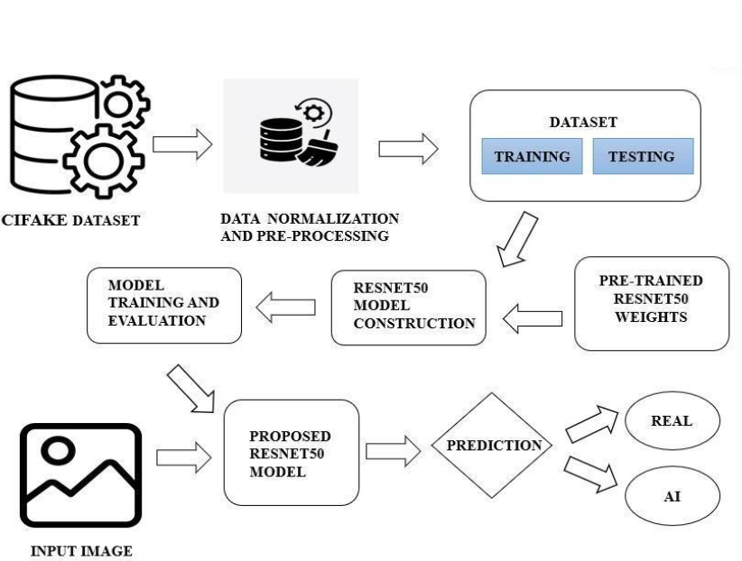
Figure 4.1: System Architecture

A System Architecture is the conceptual model that defines the structure, behavior, and more views of a system. An architecture description is a formal description and representation of a system, organized in a way that supports reasoning about the structures and behaviors of the system. A System Architecture can consist of system components and the sub-systems developed, that will work together to implement the overall system.
Implementation work flow:
Dataset: The project begins with the acquisition of image datasets containing both real and computer-generated images. These datasets serve as the foundation for training and evaluating the model.
Data Normalization and Preprocessing: Before feeding the images into the model, they undergo normalization to ensure consistency in pixel values and preprocessing to enhance features and reduce noise. This step is crucial for improving model performance.
Dataset Splitting (Training and Testing): The dataset is divided into training and testing sets. The training set is used to train the model, while the testing set is used to evaluate its performance and generalization ability.
ResNet50 Model Construction: The ResNet50model architecture is constructed. ResNet50 is a deep convolutional neural network known for its effectiveness in image
classification tasks. It consists of multiple layers, including convolutional layers, pooling layers, and fully connected layers.
Model Training: The constructed ResNet50 model is trained using the training dataset. During training, the model learns to extract meaningful features from the images and make predictions based on these features. The training process involves optimizing the model's parameters to minimize the prediction error.
Model Evaluation: Once the model is trained, it is evaluated using the testing dataset to assess its performance. The evaluation metrics, such as accuracy, precision, recall, and F1-score, provide insights into how well the model performs on unseen data.
Input Image for Prediction: User scan input an image (either real or computer-generated) into the trained model for prediction. This image undergoes preprocessing to ensure compatibility with the model's input requirements.
Prediction (Real or Fake): The trained model predicts whether the input image is real or computer-generated. This prediction is based on the features extracted by the model during training and its learned decision-making process.

Use Case Diagram :
A use case diagram illustrates user-system interactions, show casing relationships between users and different use cases. It simplifies system functionality into circles or ellipses, offering a high-level system view. Considered blueprints, they aid stakeholder comprehension and communication due to their simplistic, real-world mimicking nature. These diagrams serve to convey requirements in lay terms, facilitating stakeholder understanding. They're instrumental in gathering system requirements, identifying actors, and capturing both internal and external influences for design. Use cases, accompanied by additional documentation, offer a comprehensive view of system functionality.
Implementation Workflow:
- Upload Dataset: This use case involves users uploading images to the system for processing and analysis. Users provide images, either real or computer-generated, to be used for training, testing, or prediction purposes.
- Preprocessing: In this use case, the system preprocesses the uploaded images before using them for training, testing, or prediction. Preprocessing tasks may include normalization, resizing, noise reduction, and feature extraction to prepare the images for further analysis.0020
- Training and Testing: This Use case represents the process of training the model using the preprocessed image data. The system divides the dataset into training and testing sets, trains the model on the training set, and evaluates its performance on the testing set to assess its accuracy and generalization ability.
- Model: After training the model, this use case involves evaluating its performance using various metrics such as accuracy, precision, recall, and F1-score. The system analyzes the model's predictions against ground truth labels to determine its effectiveness in classifying images as real or fake.
- New Image to Validate Model: Users can provide new images to validate the trained model's performance. The system processes these images and compares its predictions with ground truth labels to assess the model's accuracy and reliability in real-world scenarios.
- Prediction: Users can provide new images to validate the trained model's performance. The system processes these images and compares its predictions with ground truth labels to assess the model's accuracy and reliability in real-world scenarios.

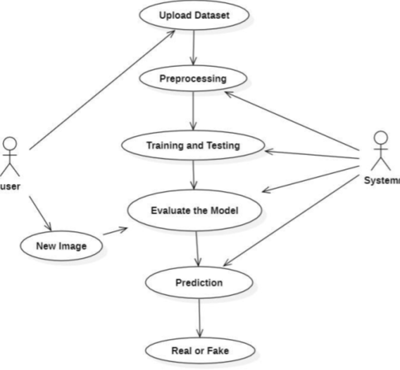
Figure 4.2 : Use Case Diagram

Activity Diagram:
Activity diagrams, while valuable for illustrating human-centric processes and interactions between actors and activities, may not be the optimal choice for representing a deep fake detection system. This is because the system's core functionality revolves around data manipulation, feature extraction, and model training, rather than active decision-making or actor interactions. As the process is predominantly data-centric and lacks direct actor involvement, using an activity diagram might not effectively capture the essence of the system. While technically feasible, it would not provide the most insightful or efficient visualization of the deep fake detection process.
Training Workflow:
- Load Dataset: The first step involves loading the dataset, which typically consists of images and their corresponding labels. This dataset will be used to train the machine learning model.
- Pre-Process image: Before training, the images need to be preprocessed to ensure consistency and improve model performance. This step might include resizing images, normalizing pixel values, or augmenting the dataset through rotations, flips, or other transformations.
- Build Model: In this step, you create the machine learning model's structure, specifying the layers and their configurations. Common model architectures include Convolutional Neural Networks(CNNs)for image classification tasks.
- Train Model: After building the model, you train it using the preprocessed dataset. The training process involves feeding the data into the model, adjusting the model's parameters through back propagation, and iterating this process for a specified number of epochs.
- Evaluate Model: Once the model is trained, it's essential to evaluate its performance on a separate validation dataset. This step helps ensure that the model generalizes well to new data and hasn't over fit or under fit the training dataset.
- Generate Confusion Matrix: A confusion matrix is at able that summarizes the performance of a classification model. It can help visualize the number of true positives, true negatives, false positives, and false negatives generated by the model.
- Predicton New Image: After evaluating the model, you can use it to predict the class of a new, unseen image. This step involves preprocessing the image similarly to the training dataset and then feeding it through the trained model to obtain a prediction.
Testing Workflow:
For the testing workflow using a deep learning approach for classifying real and computer-generated images, Deep Learning Approach for Classifying Real and Computer-Generated Images:
- Data Preparation:
  - Gather a dataset comprising both real-world and computer-generated images .
  - Preprocess the images, including resizing, normalization, and augmentation to enhance the diversity and quality of the dataset.
- Trained Model Loading :

  - Train a deep learning model, such as a convolutional neural network (CNN), on the prepared dataset.

  - Utilize frameworks like TensorFlow or PyTorch to build and train the model. Define the architecture of the CNN, including convolutional layers, pooling layers, and fully connected layers.

  - Train the model using techniques like backpropagation and optimization algorithms (e.g., Adam) to minimize loss and improve accuracy.

- Feature Extraction :
Extract key features from the cropped face image (e.g., distances between facial landmarks).

- Comparison and Matching:
- Compare the extracted features with the features stored in the trained model.
- Calculate a match score based on the comparison.

- Prediction :
- If the match score exceeds a predefined threshold, classify the face as REAL.
- Otherwise, classify the face as FAKE.
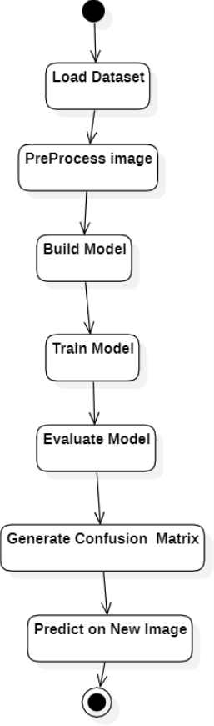
Figure 4.3 : Activity Diagram

Sequence Diagram:
A sequence diagram illustrates object interactions over time, depicting the objects and classes involved, along with the sequence of messages exchanged to execute a scenario. It's often linked to use case realizations in system development's Logical View. Life lines represent simultaneous processes or objects , with horizontal arrows denoting message exchanges. Message types are differentiated: solid arrow heads for synchronous calls, open arrow heads for asynchronous messages, and dashed lines for replies. Activation boxes depict processes triggered by messages, and objects can call methods on themselves, creating new activation boxes. Object destruction is indicated by an "X" at the lifeline's bottom, typically triggered by a message.
Implementation workflow:
- User Interaction: The user provides data to the system, which is received by the Data Handler
- Data Preprocessing: The Data Handler preprocesses the data and passes it to the Visual Analyzer.
- Model Training: The Visual Analyzer trains the model using the preprocessed data.
- Model Evaluation: After training, the Visual Analyzer evaluates the trained model's performance and passes the evaluation results to the Classification Validator.
- Prediction on New Image: The user provides a new image for prediction, which is passed to the Visual Analyzer.
- Prediction Process: The Visual Analyzer uses the trained model to predict the class of the new image and passes the prediction to the Classification Validator.
- Display Prediction: Finally, the Classification Validator displays the prediction result to the user.

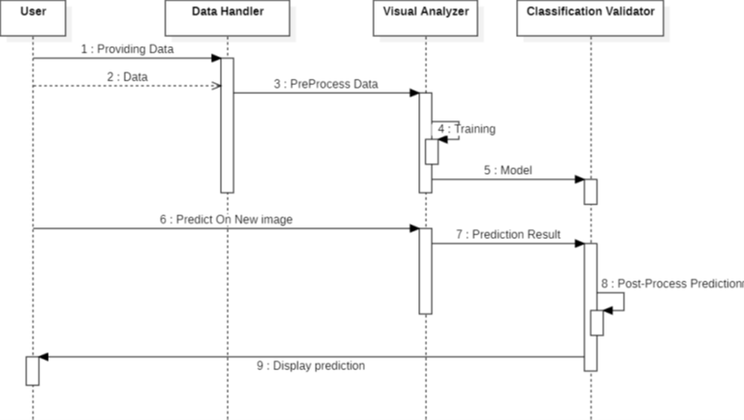
Figure 4.4 : Sequence Diagram

Class Diagram:
A class diagram in the Unified Modelling Language (UML) is a type of static structure diagram that describes the structure of a system by showing the system's classes, their attributes, operations (or methods), and the relationships among objects.
The Class Diagram is the main building block of object- oriented modelling. It is used for general conceptual modelling of the structure of the application, and for detailed modelling translating the models into programming code. Class diagrams can also be used for data modelling. The classes in a class diagram represent both the main elements, interactions in the application, and the classes to be programmed.
Classes:
- User: Represents users interacting with the system. It has methods `upload_image()` and `upload_dataset()` for uploading images and datasets, respectively.
- Data Handler: Handles data preprocessing tasks. It contains the method `preprocess () ` for preprocessing uploaded datasets.
- Visual Analyzer: Manages the compilation and training of machine learning models. It includes methods `compile_model()` for compiling the model architecture and ‘train_model()` for training the compiled model.
- Classification Validator: Handles model evaluation and validation tasks. It provides methods `evaluate_model() `for evaluating the trained model's performance and `plot_confusion_matrix()` for visualizing the confusion matrix.

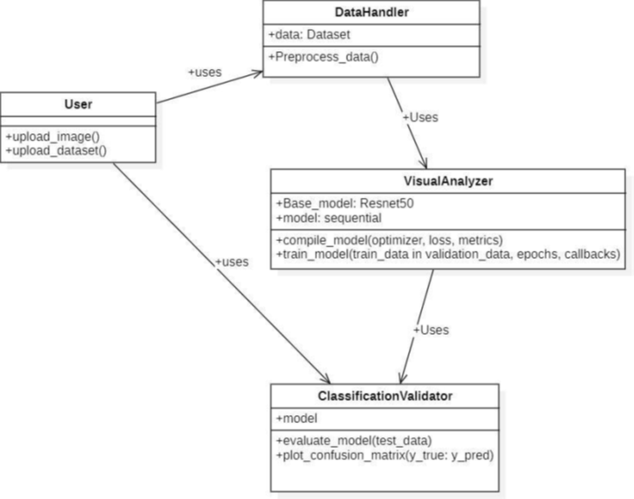
Figure 4.5 : : Class Diagram

System Implementation

Tools and technologies used:

UML Tools:
- Star UML: Software modeler that uses Unified Modelling Language (UML) to support system and software modelling.

Programming Languages:
- Python3:Python3 is a powerful, high-level programming language known for its simplicity and readability. It is widely used for web development, data analysis, artificial intelligence, and automation tasks.

Programming Frameworks:
- TensorFlow: TensorFlow is the primary deep learning framework used throughout the code. It provides the foundational building blocks for defining computational graphs, performing automatic differentiation, and optimizing neural network models. TensorFlow offers a high degree of flexibility and scalability for training and deploying machine learning models.
- Keras: Keras is an integral part of TensorFlow and serves as its high-level API. It provides a user-friendly interface for defining neural network models, layers, and training procedures. In the code, Keras is used for constructing the model architecture, compiling models with optimizers and loss functions, and training models with training loops and callbacks.
- Streamlit: Streamlit is an open-source Python library designed for creating interactive web applications focused on data science and machine learning. It simplifies the process by allowing developers to build web interfaces directly from Python scripts, eliminating the need for additional web development knowledge. With Streamlit's intuitive syntax and automatic updates, users can rapidly prototype, iterate, and deploy applications. It offers a range of built-in widgets for user interaction and seamlessly integrates with popular Python libraries like Pandas and Matplotlib for data visualization. Overall, Streamlit empowers developers and data scientists to effortlessly share insights, prototypes, and machine learning models through intuitive and customizable web applications.

IDE:
- Google Colab: Google Colab is a cloud-based platform that provides free access to Jupyter notebooks with GPU and TPU acceleration for Python programming, facilitating collaborative coding and data analysis.
- Visual Studio Code: Visual Studio Code (VS Code) is a lightweight and highly customizable code editor developed by Microsoft, widely used by developers for various programming languages with features like debugging, syntax highlighting, and extensions support.

Libraries:
- TensorFlow and TensorFlow.keras: TensorFlow is an open-source machine learning framework developed by Google. It provides a comprehensive ecosystem of tools and libraries for building and deploying machine learning models. TensorFlow. keras is TensorFlow's high-level API for building and training deep learning models. It offers an easy-to-use interface for defining neural network architectures, compiling models with optimizers and loss functions, and training models efficiently.
- Matplotlib: Matplotlib is a widely-used plotting library in Python for creating static, interactive, and animated visualizations. Matplotlib is primarily used for visualizing images, plotting training/validation curves, and displaying various statistical plots.
- Numpy:NumPy is a fundamental package for numerical computing in Python. It provides support for large, multi-dimensional arrays and matrices, along with a collection of mathematical functions to operate on these arrays efficiently. NumPy is extensively used for array manipulation, image processing, and performing mathematical operations on data.
- OpenCV (cv2): OpenCV (Open Source Computer Vision Library) is a popular computer vision library with extensive support for image and video processing tasks.OpenCV is used for reading images from files, resizing images to the desired dimensions, and converting color spaces.
- Seaborn: Seaborn is a statistical data visualization library based on Matplotlib. It provides a high-level interface for creating informative and attractive statistical graphics. Seaborn is utilized for creating more complex and visually appealing plots, such as heatmaps for displaying confusion matrices.
- Scikit-learn: scikit-learn is a machine learning library in Python that provides simple and efficient tools for data mining and data analysis. In the code, scikit-learn is used for computing metrics such as precision, recall, and confusion matrices.

Algorithm Details:

Dataset Details:
- CIFAKE Dataset: The CIFAKE dataset represents a curated collection of images curated specifically for binary image classification endeavors. It encompasses two discernible categories: AI-generated (fake) images and authentic real images, each offering distinct visual characteristics. These images undergo a standardized preprocessing regimen, ensuring uniformity in size, with all images resized to a uniform 32 x 32-pixel resolution. The dataset is meticulously partitioned into training, validation, and test sets, each tailored to support robust model training and evaluation processes. As a fundamental resource in the realm of machine learning and computer vision, the CIFAKE dataset provides researchers and practitioners with a comprehensive platform for exploring and advancing image classification methodologies. Acknowledging the dataset creators and adhering to any prescribed citation norms or usage guidelines is imperative to fostering a collaborative and ethical research environment.

Preprocessing Details
In our project, preprocessing plays a crucial role in preparing the input data for training and inference in the machine learning model. Here's an overview of the preprocessing techniques used:
- Image Loading and Resizing: We load images from the dataset using OpenCV's 'imread' function. Input images are resized to a fixed size (e.g., 32x32 pixels) to ensure uniformity and compatibility with the model's input layer.
- Data Normalization: Pixel values of images are normalized to the range [0, 1] by dividing by 255. This standardizes the pixel intensity values and facilitates model convergence during training.
- Data Augmentation: Data augmentation techniques such as random flips, rotations, and brightness adjustments may be applied to artificially increase the diversity of the training dataset.
- Dataset Splitting: The dataset is split into training, validation, and test sets to evaluate model performance accurately. Typically, the data is divided into 70% for training, 20% for validation, and 10% for testing.
- Data Pipeline: TensorFlow's data pipeline APIs, such as 'tf.data.Dataset', are used to efficiently preprocess and prepare batches of data for training, ensuring seamless integration with the model.
- Visualization: Sample images from the dataset are visualized before and after preprocessing to validate the transformations and ensure data integrity.

Benefits:
- Preprocessing ensures that the input data is in a suitable format and distribution for effective model training.
- Augmentation techniques enhance the dataset's diversity, leading to better model generalization and robustness.
- Standardization and normalization improve convergence and stability during training, resulting in faster and more reliable model performance.

Preprocessing Code:
# To download the data set from Kaggle
!pip install opendatasets
import opendatasets as od
od.download('https://www.kaggle.com/datasets/birdy654/cifake-real-and-ai-generated-synthetic-images?resource=download')
# Printing the GPU
import tensorflow as tf
gpus = tf.config.experimental.list_physical_devices('GPU')
for gpu in gpus:
tf.config.experimental.set_memory_growth(gpu, True)
# To know the number of images in training the dataset
data = tf.keras.utils.image_dataset_from_directory('/content/cifake-real-and-ai-generated-synthetic-images/train', image_size=(32, 32))
# Visualizing of sample set of images
import matplotlib.pyplot as plt
data_it = data.as_numpy_iterator()
batch = data_it.next()
fig, ax = plt.subplots(ncols=8, figsize=(10, 10))
for idx, img in enumerate(batch[0][:8]):
ax[idx].imshow(img.astype(int))
ax[idx].title.set_text(batch[1][idx])
# The batch size is automatically set to 32 in image_dataset_from_directory()
print(f"Number of images in each batch: {len(batch[0])}")
# Preprocessing the Dataset
data = data.map(lambda x, y : (x/255, y))
scaled_it = data.as_numpy_iterator()
batch = scaled_it.next()
fig, ax = plt.subplots(ncols=8, figsize=(10, 10))
for idx, img in enumerate(batch[0][:8]):
ax[idx].imshow(img.astype(float))
ax[idx].title.set_text(batch[1][idx])
# Splitting Data to Train, Test, Validation
train_size = int(len(data) * 0.7)
cv_size = int(len(data) * 0.2)
test_size = int(len(data) * 0.1) + 1
train = data.take(train_size)
cv = data.skip(train_size).take(cv_size)
test = data.skip(train_size + cv_size).take(test_size)
print("Train: ",len(train))
print("Test: ", len(test))
print("Val: ",len(cv))
# Checking how many images for each one
print("Number of images in train: ",(len(train))*32)
print("Number of images in Val: ",(len(cv))*32)
print("Number of images in test: ",(len(test))*32)
print("Total number of images: ",(len(train)+len(cv)+len(test))*32)

Model Details:
During the initial evolution of convolution neural networks (CNN), boosting accuracy meant creating deeper models by stacking layer upon layer. However, a pivotal moment emerged when the quest for deeper models hit a roadblock. As researchers delved into deeper models for better accuracy, the once-promising path led to a puzzling paradox: the deeper the model, the more elusive accuracy became!
Then came ResNet50, like a superhero. Instead of just piling on more layers, ResNet50 had this cool trick called "residual learning" that allowed the models to be deeper and yet, still be accurate.
RESNET50: ResNet50 is a deep learning model launched in 2015 by Microsoft Research for the purpose of visual recognition. ResNet is short for Residual Networks while the ‘50’ just means that the model is 50 layers deep.
The complete architecture of ResNet50 is composed of four parts:
- Convolution layers: These layers play a fundamental role in feature extraction. Convolution involves applying filters to input images, allowing the model to detect various patterns, edges, and textures within the data.
- Convolution blocks: These blocks are composed of multiple convolution layers, often followed by normalization and activation functions. They facilitate the extraction of high-level features from the input data.
- Residual blocks: Residual blocks serve as shortcuts or skip connections that allow the model to skip one or more layers. This helps in mitigating the vanishing gradient problem during training and aids in the smooth flow of information.
- Fully connected layers: These layers are responsible for making predictions based on the extracted features. In the context of ResNet, the fully connected layers map the learned features to the final output classes.

The groundbreaking contribution of ResNet is the introduction of the residual block.

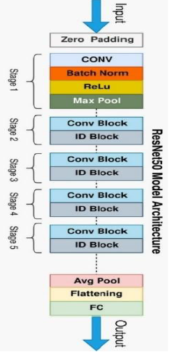
Figure 5.1 : ResNet50 Model Architecture

Figure 5.2 : Residual Learning Block

ReLU: A Rectified Linear Unit is activation function that has output 0 if the input is less than 0, and raw output otherwise. That is, if the input is greater than 0, the output is equal to the input. The operation of ReLU is closer to the way our biological neurons work. ReLU is non-linear and has the advantage of not having any backpropagation errors unlike the sigmoid function, also for larger Neural Networks, the speed of building models based off on ReLU is very fast.
Figure 5.3 : Relu Activation Function

Dropout Layer:Dropout layer with the value of 0.5 is used to avoid overfitting in the model and it can help a model generalize by randomly setting the output for a given neuron to 0. In setting the output to 0, the cost function becomes more sensitive to neighboring neurons changing the way the weights will be updated during the process of backpropagation.

Figure 5.4 : Dropout layer overview

Model Training Details:
- Data Loading and Preprocessing:
The dataset is loaded from the specified directory and resized to (32, 32) pixels, while pixel values are normalized to the range [0, 1].
- Train-Test-Validation Split:
The dataset is split into training, validation, and test sets with proportions of 70%, 20%, and 10%, respectively, using the `take()` and `skip()` methods.
- Model Architecture:
A ResNet50 base model pre-trained on ImageNet is loaded, followed by custom dense layers added for classification.
- Model Compilation:
The model is compiled with the Adam optimizer using a learning rate of 0.001 and binary cross-entropy loss.
- Data Augmentation:
Data augmentation techniques such as random flips, brightness adjustments, and contrast modifications are applied to the training dataset to increase dataset diversity.
- Learning Rate Scheduler:
A learning rate scheduler is defined to adjust the learning rate during training epochs, decreasing it by 5% at the end of each epoch.
- Early Stopping:
Early stopping is implemented to monitor validation loss, allowing training to stop if there is no improvement for 3 consecutive epochs, restoring the best weights.
- Model Training:
The model is trained on the augmented training dataset for 10 epochs, with callbacks for learning rate scheduling and early stopping.
- Evaluation:
The trained model is evaluated on the test set to assess its performance, and the test accuracy is printed.
- Plotting Training History:
The training and validation accuracy and loss metrics are plotted over epochs to visualize the training progress and model performance.
- Cross Entropy:
To calculate the loss function Cross Entropy approach is used because we are training a classification problem.
- Sigmoid Function:
It is used as the activation function for the final layer of the model. This is because the sigmoid function maps any real-valued number to a probability value between 0 and 1. Therefore, it is suitable for binary classification problems.
Training Code:
# To download the data set from kaggle
!pip install opendatasets
import opendatasets as od
od.download('https://www.kaggle.com/datasets/birdy654/cifake-real-and-ai-generated-synthetic-images?resource=download')
# To know the number of images in Training the Dataset
data = tf.keras.utils.image_dataset_from_directory('/content/cifake-real-and-ai-generated-synthetic-images/train', image_size=(32, 32))
# Preprocessing the Dataset
data = data.map(lambda x, y : (x/255, y))
# Splitting Data to Train, Test, Validation
train_size = int(len(data) * 0.7)
cv_size = int(len(data) * 0.2)
test_size = int(len(data) * 0.1) + 1
train = data.take(train_size)
cv = data.skip(train_size).take(cv_size)
test = data.skip(train_size + cv_size).take(test_size)
print("Train: ",len(train))
print("Test: ", len(test))
print("Val: ",len(cv))
# Model Building
from tensorflow.keras.applications import ResNet50
from tensorflow.keras import layers, models
base_model = ResNet50(weights='imagenet', include_top=False, input_shape=(32, 32, 3))
model = models.Sequential()
model.add(base_model)
model.add(layers.Flatten())
model.add(layers.Dense(256, activation='relu'))
model.add(layers.BatchNormalization())
model.add(layers.Dropout(0.5))
model.add(layers.Dense(128, activation='relu'))
model.add(layers.Dense(1, activation='sigmoid'))
# Overview of the Model
model.summary()
# Learning Rate Scheduler
from tensorflow.keras.callbacks import LearningRateScheduler, EarlyStopping
from tensorflow.keras.optimizers import Adam
initial_learning_rate = 0.001
def lr_scheduler(epoch, lr):
return lr * 0.95
lr_schedule = LearningRateScheduler(lr_scheduler)
optimizer = Adam(learning_rate=initial_learning_rate)
# Compiling the model
model.compile(optimizer=optimizer, loss='binary_crossentropy', metrics=['accuracy'])
# Data Augumentation
def augment_data(x, y):
x = tf.image.random_flip_left_right(x)
x = tf.image.random_flip_up_down(x)
x = tf.image.random_brightness(x, max_delta=0.1)
x = tf.image.random_contrast(x, lower=0.9, upper=1.1)
return x, y
train_augmented = data.map(augment_data)
# Model Training
# Early Stopping
early_tfgystopping = EarlyStopping(monitor='val_loss', patience=3, restore_best_weights=True)
# Train the model
history = model.fit(train_augmented, validation_data=cv, epochs=10, callbacks=[lr_schedule, early_stopping])
# Evaluate the model on the test set
test_loss, test_accuracy = model.evaluate(test)
print(f'Test Accuracy: {test_accuracy * 100:.2f}%')
# Plot accuracy and loss
plt.figure(figsize=(12, 4))
# Plot training & validation accuracy values
plt.subplot(1, 2, 1)
plt.plot(history.history['accuracy'])
plt.plot(history.history['val_accuracy'])
plt.title('Model accuracy')
plt.xlabel('Epoch')
plt.ylabel('Accuracy')
plt.legend(['Train', 'Validation'], loc='upper left')
# Plot training & validation loss values
plt.subplot(1, 2, 2)
plt.plot(history.history['loss'])
plt.plot(history.history['val_loss'])
plt.title('Model loss')
plt.xlabel('Epoch')
plt.ylabel('Loss')
plt.legend(['Train', 'Validation'], loc='upper left')
plt.tight_layout()
plt.show()

Model Prediction Details:
Load the Trained Model:
The model trained earlier is loaded from the saved location.
Read and Preprocess the Image:
The new image is read using OpenCV (cv2.imread()), resized to (800, 600) pixels, and converted from BGR to RGB format.
Display the Image:
The preprocessed image is displayed using Matplotlib (plt.imshow()).
Preprocess the Image for Prediction:
The image is resized to (32, 32) pixels and normalized by dividing by 255 to scale pixel values between 0 and 1. Additionally, a batch dimension is added.
Make Predictions:
The preprocessed image is passed to the loaded model for making predictions.

Display Prediction Result:
Based on the prediction probability, the predicted class is displayed as "REAL" if the probability is greater than 0.5, otherwise as "AI".

Prediction Code:
# To download the data set from kaggle
!pip install opendatasets
import opendatasets as od
od.download('https://www.kaggle.com/datasets/birdy654/cifake-real-and-ai-generated-synthetic-images?resource=download')
# Model Prediction On Any Single Image
import cv2
image_path = '/content/cifake-real-and-ai-generated-synthetic-images/train/REAL/0001 (5).jpg'
try:
img = cv2.imread(image_path)
if img is None:
raise FileNotFoundError(f"Could not read the image from {image_path}")
img = cv2.resize(img, (800, 600))
img = cv2.cvtColor(img, cv2.COLOR_BGR2RGB)
plt.imshow(img)
plt.show()
except Exception as e:
print(f"Error: {e}")

# Resize and normalize the image for prediction
import numpy as np
resize = tf.image.resize(img, (32, 32))
y_pred = model.predict(np.expand_dims(resize/255, 0))
y_pred
# Display the prediction result
if y_pred > 0.5:
print(f'Predicted class: REAL')
else:
print(f'Predicted class: AI')

Testing and Results

Testing
Testing in our project is crucial as it ensures the reliability, accuracy, and functionality of the image classification model. It helps identify and rectify any potential issues or bugs, ensuring that the model performs as expected and meets the specified requirements. Additionally, testing ensures that the model can generalize well to unseen data and performs effectively in real-world scenarios.

Functional Testing:
Functional testing ensures that each component of the system functions correctly according to its specifications and requirements:
- Data Loading: Verify that the system can successfully load image datasets from the specified directory and that the images are correctly parsed.
- Preprocessing: Ensure that preprocessing steps such as resizing and normalization are applied accurately to the input images, preparing them for model input.
- Model Training: Validate that the model training process proceeds smoothly, with the model architecture being correctly defined, optimizer configured, and loss function applied.
- Model Evaluation: Confirm that the trained model can accurately evaluate images from the test dataset, producing meaningful predictions and performance metrics.
- Prediction: Test the model's ability to make accurate predictions on new images, ensuring that it performs as expected in real-world scenarios.

Non-functional Testing:
Non-functional testing focuses on evaluating the performance, usability, security, scalability, and reliability aspects of the image classification system to ensure it meets quality standards and user expectations
- Performance Testing: Performance Testing: Evaluate the model's performance in terms of inference speed and resource utilization, ensuring that it meets performance requirements under varying workloads.
- Security Testing: Identify and address potential security vulnerabilities in the system, such as data leakage or model poisoning attacks, to safeguard sensitive information.
- Usability Testing: Assess the user interface and interaction flow of the system to ensure it is intuitive, user-friendly, and accessible to its intended users.
- Scalability Testing:
  - Test the system's ability to handle increasing amounts of data or user requests, ensuring that it can scale effectively as the workload grows.
  - These testing types ensure that the application functions correctly, efficiently, and reliably under various conditions, providing a robust user experience.

Table 6.1 : Non-functional Testing
Case id | Test Case Description | Expected Result | Actual Result | Status
1 | Upload a word file instead of Video | Error message: Only images files allowed | Error message: Only images files allowed | Pass
2 | Upload a 200MB video file | Error message: Max limit 100MB | Error message: Max limit 100MB | Pass
3 | Upload a file without any faces | Error message: No faces detected. Cannot Process the video | Error message: No faces detected. Cannot Process the video | Pass
4 | images with many faces | Fake/Real | Fake | Pass
5 | AI Image | Fake | Fake | Pass
6 | Enter/predict in URL | Redirect to /Upload | Redirect to /Upload | Pass
7 | Press upload button without selecting images | Real | Real | Pass
8 | Upload a Real Image | Real | Real | Pass
9 | Upload a face cropped real Images | Real | Real | Pass
10 | Upload a face cropped | Fake | Fake | Pass

Output Screens
Figure 6.1 : Model Accuracy Plots

Above are the plots visualizing the training and validation accuracy/loss over epochs. The left subplot illustrates model accuracy, with the solid blue line indicating training accuracy and the dashed orange line showing validation accuracy. On the right, model loss is displayed, with the blue line representing training loss and the orange line indicating validation loss. These plots offer insights into the model's performance during training, helping to identify potential overfitting or underfitting. The aim is to observe convergence in accuracy and loss values, indicating successful model training.
Figure 6.2 : Confusion Matrix Representation
Based on the provided confusion matrix, our model achieved 1934 true positives (TP), 122 false positives (FP), 40 false negatives (FN), and 256 true negatives (TN). These metrics offer valuable insights into the performance of our system.
Figure 6.3 : Classification Report
Examining the classification report, we observe a high precision of 0.98 for classifying AI images, indicating a low false positive rate. However, for REAL images, precision is lower at 0.57, suggesting a higher false positive rate in this category. Furthermore, analyzing recall values reveals that the model effectively captures a large proportion of both AI and REAL images. The recall values for AI and REAL images are 0.89 and 0.88, respectively, demonstrating the model's ability to correctly identify instances of both classes.
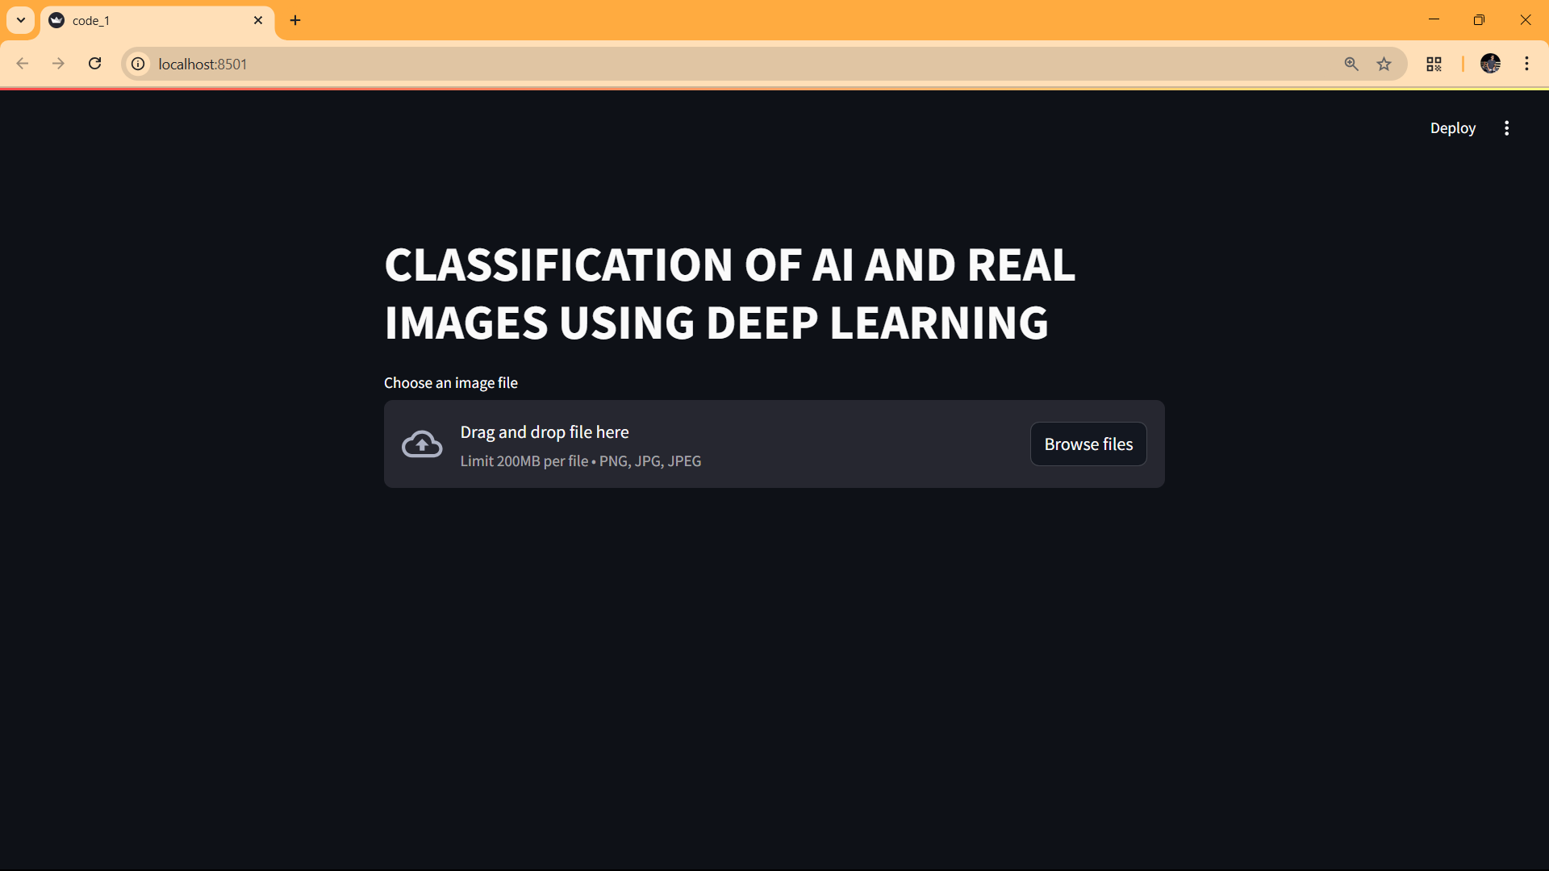
Figure 6.4 : Home page of our Project

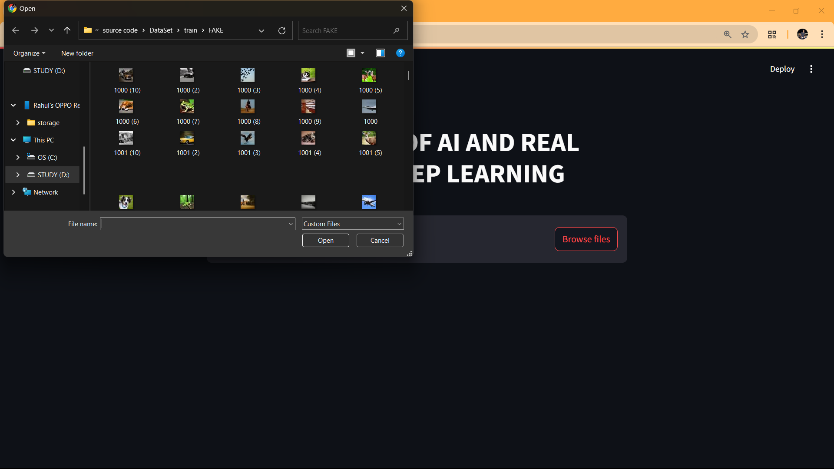
Figure 6.5 : Selecting an Image

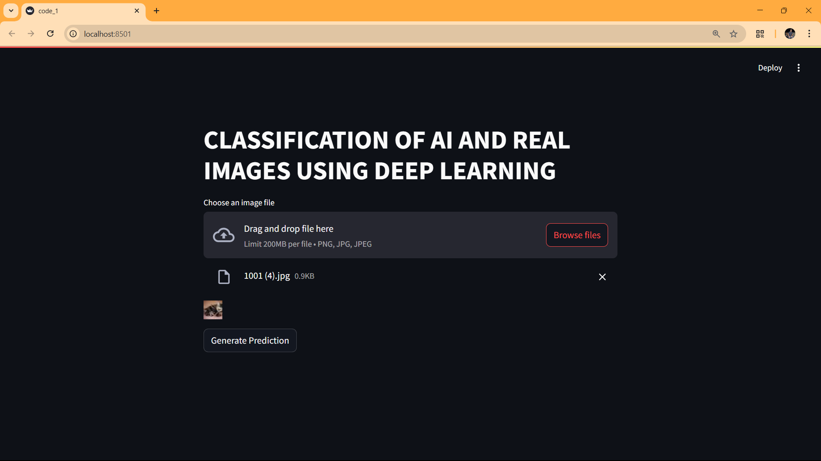
Figure 6.6 : Fake Image Uploaded successfully

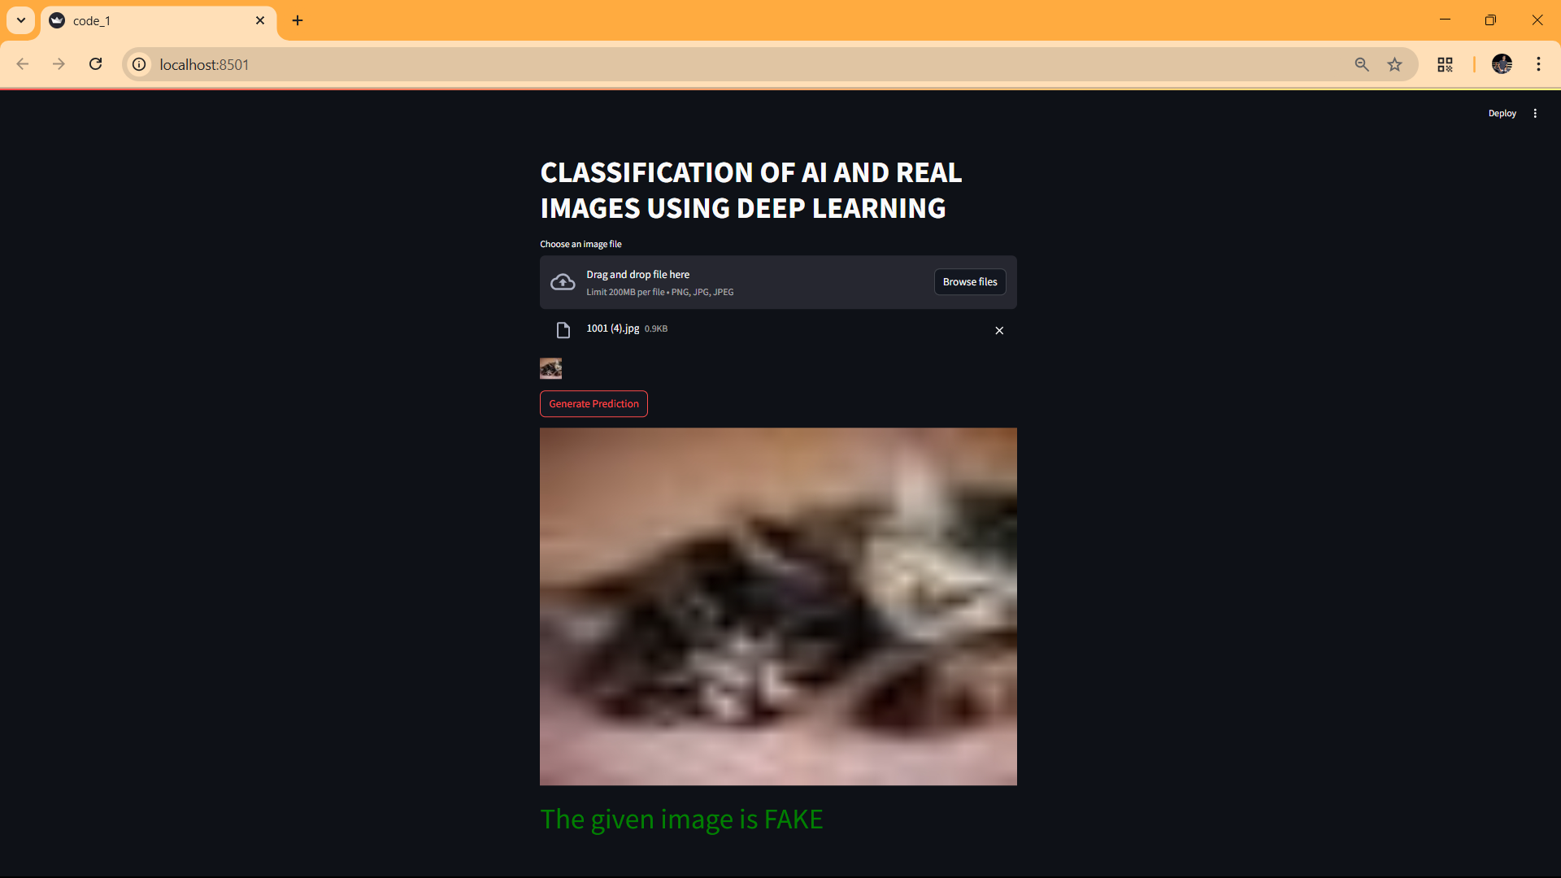
Figure 6.7 : Fake Image is predicted as Fake

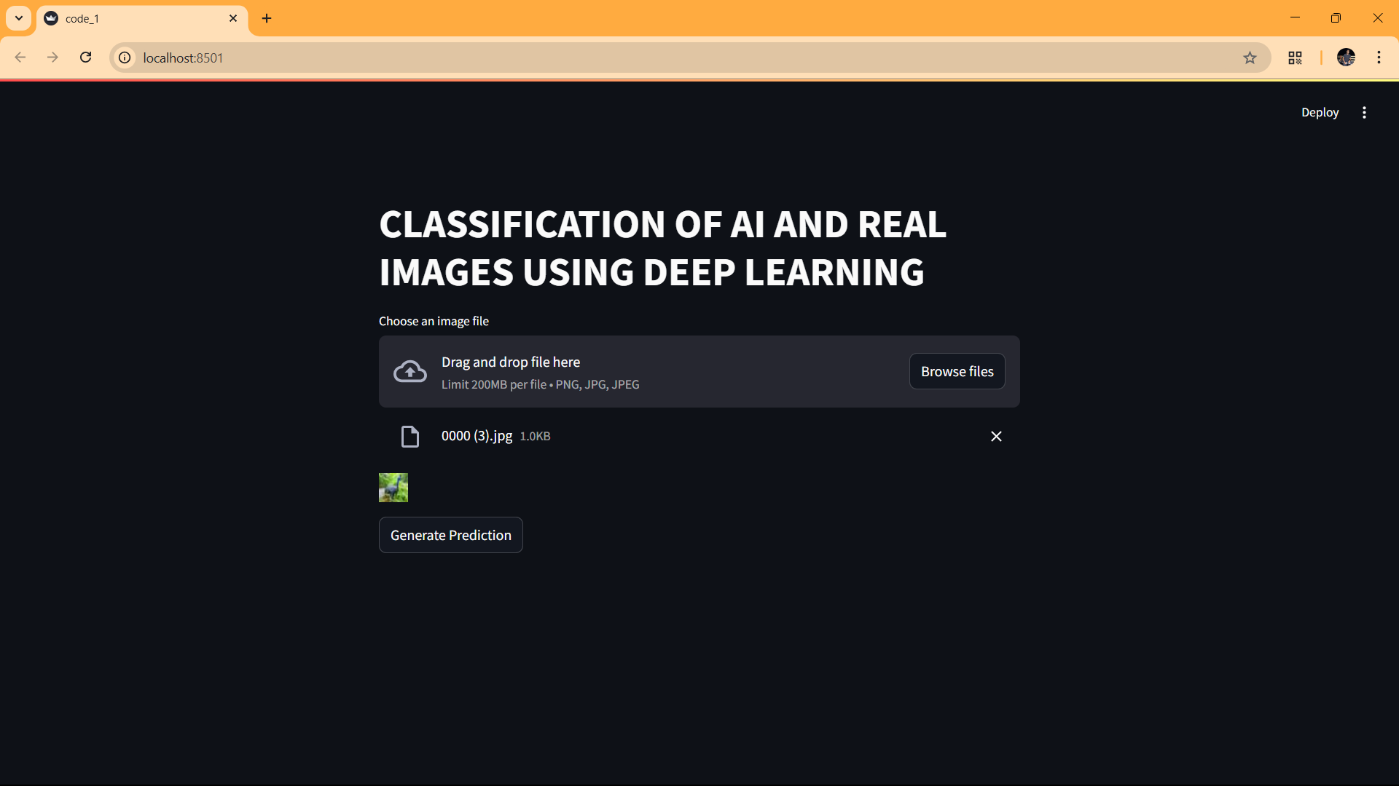
Figure 6.8 : Real Image Uploaded successfully

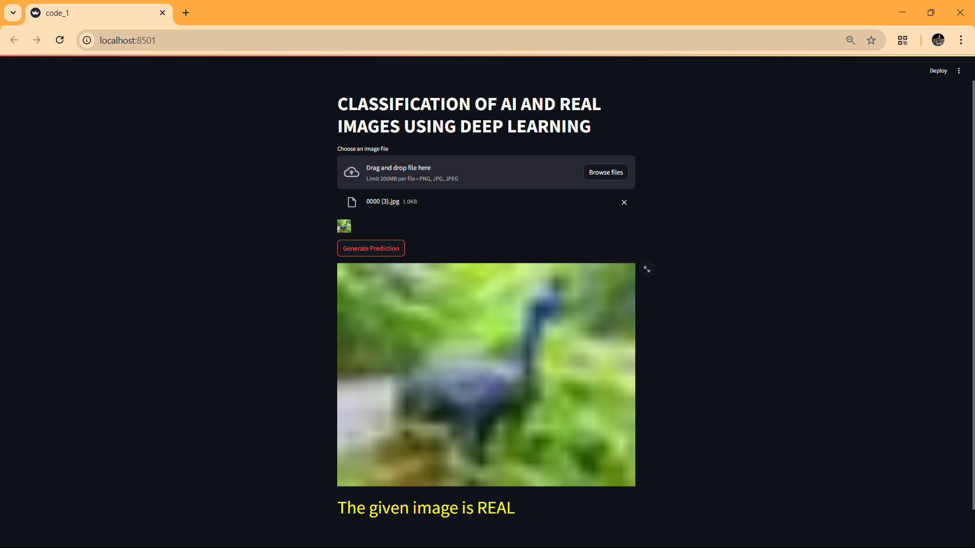
Figure 6.9 : Real Image is Predicted as Real

Conclusions And Future Scope

Conclusion:
In conclusion, our project has successfully developed an effective image classifier capable of distinguishing between AI generated and real images. Leveraging a deep learning approach with a ResNet50 convolutional neural network, we have achieved promising results in accurately classifying images. Through meticulous training, rigorous evaluation, and practical validation, our model demonstrates robust performance in real-world scenarios. The integration of data augmentation techniques, early stopping, and learning rate scheduling has further enhanced the model's accuracy and generalization capabilities. Our project contributes to the advancement of image classification techniques and holds potential for various applications, including content moderation, image authentication, and digital forensics. Moving forward, continued refinement and optimization of the model, along with exploration of advanced techniques and datasets, will further elevate its performance and applicability in diverse domains.

Future Scope:
In the future, we aim to develop tools that can spot and mark parts of images created by AI, even if they're different from the original. For example, if a photo originally shows one person but an AI version adds another, our tools would detect and highlight the added person. We'll use smart techniques to analyse images and figure out what's been changed by AI. This can be handy for tasks like checking if photos have been altered or identifying fake content online. By making these tools understandable and reliable, we can help ensure that images we see are genuine and trustworthy, even in a world where AI can create convincing fakes.

References:
- Zhang, RS., Quan, WZ., Fan, LB. et al. Distinguishing Computer-Generated Images from Natural Images Using Channel and Pixel Correlation. J. Comput. Sci. Technol. 35, 592–602 (2020). https://doi.org/10.1007/s11390-020-0216-9
- D. Deb, J. Zhang, and A. K. Jain, “Advfaces: Adversarial face synthesis,” in 2020 IEEE International JointConference on Biometrics (IJCB), pp. 1–10, IEEE, 2020.
- S. Nightingale, K. Wade, and D. Watson,“Can people identify original and manipulatedphotos of real-world scenes?”Cognitive Research: Principles and Implications, pp. 2–30,2017.
- Afchar, D., Nozick, V., Yamagishi, J., Echizen, I.: Mesonet: a compact facial video forgery detection network. In: IEEE WIFS (2018).
- E. Tokuda, H. Pedrini, and A. Rocha, “Computer generated images vs. digital photographs: A synergetic feature and classifier combination approach,” Journal of Visual Communication and Image Representation, vol. 24, no. 8, pp. 1276–1292, 2013.
- M. Chhabra and R. Kumar, "An Efficient ResNet-50 based Intelligent Deep LearningModel to Predict Pneumonia from Medical Images," 2022 International Conference on Sustainable Computing and Data Communication Systems (ICSCDS), Erode, India, 2022, pp. 1714-1721, doi: 10.1109/ICSCDS53736.2022.9760995.
- https://miro.medium.com/v2/resize:fit:1400/0*tH9evuOFqk8F41FG.png

